Activity Rundown:
It's time to celebrate the Sunny weather this May long weekend with our sensational solar activity! This weekend buckle down and build your own DIY Solar Oven. Then spend the day watching the sun Cook some tasty treats, or create an innovative STEM project! Now, if the weather isn’t ideal, like a typical May long weekend, build the project and save it to test on a really sunny day.

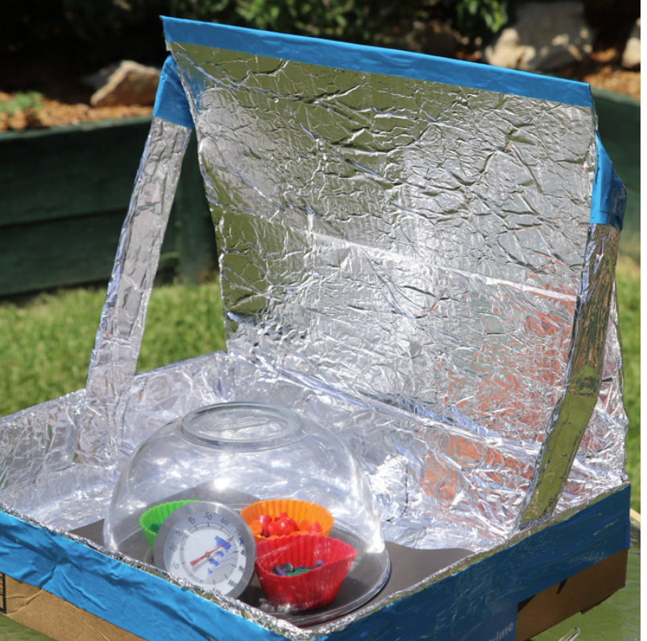

You will need:
- Cardboard box,
- Extra cardboard
- Tinfoil,
- Tape
- Glue
- Scissors
- 2 Glass bowls
- Plastic wrap skewers
Optional materials for decoration:
- Cupcake holders
- Chocolate
- Marshmallows
- Nuts
- Shaved coconut
- Scrap/old Crayons

Let’s do it!
- Start by gathering all the materials listed in above.
- This project will begin by taping the box together, making sure the bottom and lid are completely sealed.
- Now cut around the top of the box on three sides, the box should now have a flip-up lid! It should have the ability to open up just like a pizza box. If you have a pizza box already, then you won’t need to make your own.
- Now using some extra cardboard cut out two rectangular pieces. These will be used as supports to hold the lid open. 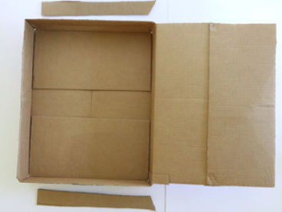
- Using the glue and tin foil, cover the inside of the box and lid as well as the two supports.
- Now tape the supports to the lid about ⅓ of the wat from the open end.
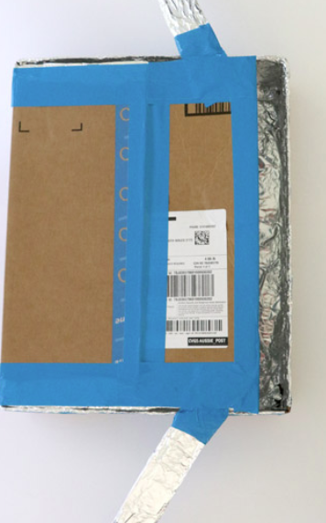
- Using the support to prop the lid open at approximately a 45-degree angle, and your solar oven is complete. 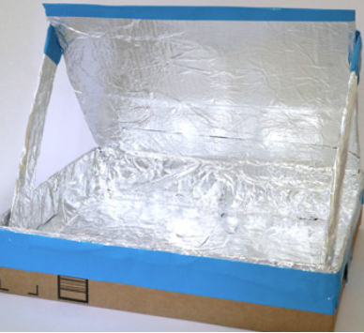
- To use your solar oven, place it outside in direct sunlight with a piece of black construction paper in the bottom, place whatever you are cooking on the paper and place a clear glass bowl over top! Even on a cold but sunny day, the oven can reach 100 degrees celsius!!!

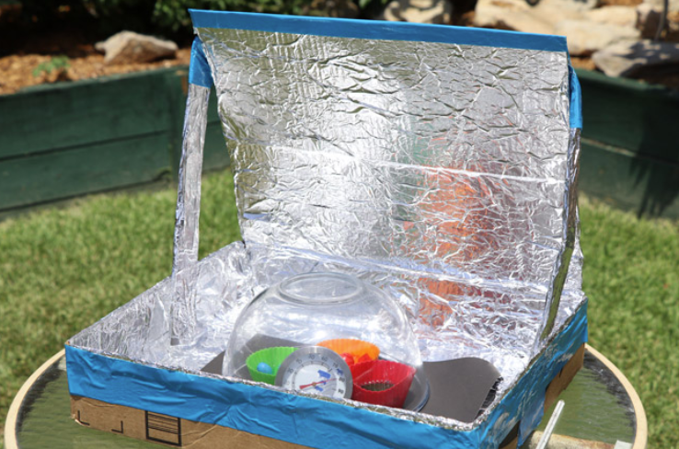

Solar oven Recipes:

Home-made rainbow crayons:
Use the leftover ends of old crayons or chop up some new ones! Mix and match or put all the same colour together, it's time to experiment! Place the crayon bits into cupcake holders and set them in the solar oven, that’s it you’re done! You can walk away or sit and watch the sun do all the work, be sure to check on the crayons in about 30 -50 min as they should be melted and ready to cool!
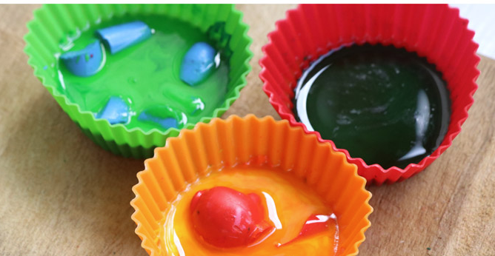

Homemade chocolate treats:
Cut up some of your favourite chocolate bars into small pieces, along with some nuts, shaved coconut and marshmallows (or whatever you want to create your chocolate treat). Now fill some cupcake holders halfway full with the mix and set them in your solar oven to cook. Make sure to check on it in about 1 hour. The treats should be ready to cool!

Resources:
- https://www.thecrafttrain.com/diy-solar-oven/

Reach out!
We would love to hear from you about all the amazing STEM projects you are doing at home! Show us your finished products on any of the following social media platforms by tagging us or by using the following hashtags. We hope these projects have brought some excitement to your day during these difficult times.
Let us know how we did! Please click here to fill out a short survey on how well we did and what you would like to see more of in the future. Thank you!
Twitter: @MyMindsInMotion
Facebook: @mindsinmotion2014 & @ucactiveliving
Instagram: @ucalgaryactive

Please use the following hashtags!
#ucalgarycamps #ucalgarytogether

We hope you enjoyed our STEM victoria day long weekend activity! Everyone at Minds in Motion would like to wish you and those closest to you a happy May long!

