Activity Rundown:
Legend has it, if you catch a leprechaun they have to tell you where their pot of gold is! Usually they have it hidden at the end of the rainbow. What if instead of chasing the leprechaun we went right to the source and created our own rainbow! Join us in creating density based rainbows and celebrate St. Patty's day in a few new way!

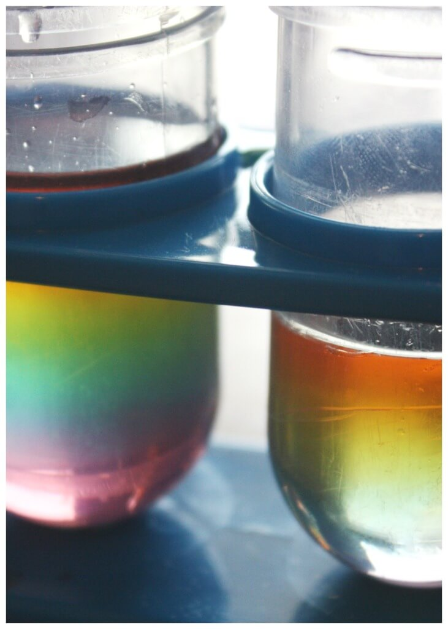

You will need:
- 4 glasses or cups
- Sugar
- Measuring spoons
- Food coloring
- Eye dropper or baster
- A tall narrow glass or test tube
Let’s do it!
- Start by filling each glass with about 1 cup of water.
- Then add 2-4 drops of red, yellow, blue, and green food colouring to one glass each.
- Mix each glass up and now we should have one glass each of blue, red, green and yellow water.

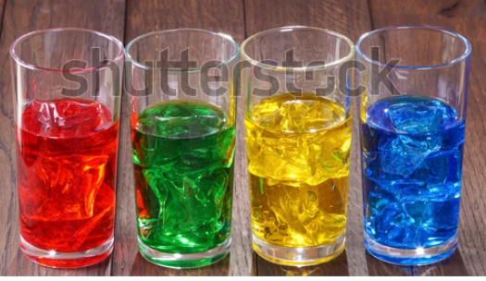

- Now measure different amounts of sugar into each glass:
  - Red = 2tbsp
  - Yellow = 4tbsp
  - Green = 6tbsp
  - Blue = 8tbsp
- Stir the Sugar till it is all dissolved, by adding the sugar we have changed the density of the solution. The more sugar in the solution the more dense or heavier it is.
- Now put a layer of the blue water into the bottom of your tall thin glass/test tube. This is the first layer of your rainbow.
- Using the eyedropper or baster, pick up some of the green sugar water. Now place the end of the baster or eye dropper against the side of the glass and very slowly release the green water into the glass. It should form a layer on top of the blue water. With a small layer of mixing between the two.
- Repeat step seven with the yellow and then red water. Now you have created your own Density rainbow! These last steps can be very difficult. The trick is to go as slowly as possible and if it doesn't work the first time try and try again!
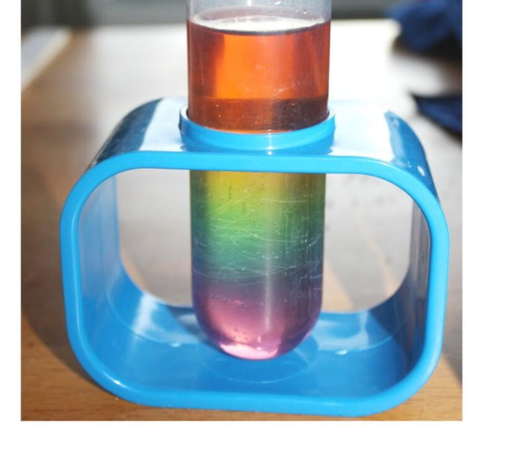
Why this Works!
Density is all about how much stuff there is in a defined amount of space! Since we used the same amount of water for each colour, the amount of space (or water) is always the same. However, we changed how much sugar we added to each glass, this allowed us to increase the density of our solutions as we went down the rainbow. The solutions stay in layers since we laid the colors in decreasing weight!

Resources:
- https://littlebinsforlittlehands.com/sugar-water-density-rainbow-science-experiment/

Reach out!
We would love to hear from you about all the amazing STEM projects you are doing at home! Show us your finished products on any of the following social media platforms by tagging us or by using the following hashtags. We hope these projects have brought some excitement to your day during these difficult times.
Let us know how we did! Please click here to fill out a short survey on how well we did and what you would like to see more of in the future. Thank you!
Twitter: @MyMindsInMotion
Facebook: @mindsinmotion2014 & @ucactiveliving
Instagram: @ucalgaryactive

Please use the following hashtags!
#ucalgarycamps #ucalgarytogether

We hope you enjoyed our STEM St. Patrick’s Day activity! Everyone at Minds in Motion would like to wish you and those closest to you a happy holiday!

