Activity Rundown:
Everyone loves getting in the Christmas spirit and one of the best activities to do that is to set up the Christmas tree! On the other hand there is always the not so fun task of taking it down. Today, we have a new and improved method to take down a christmas tree nice and easy using STEM!

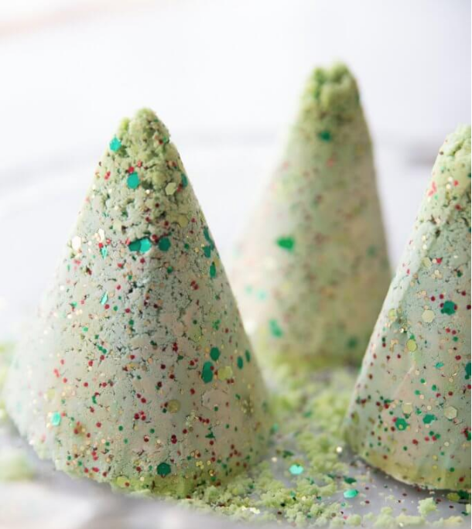

You will need:
- Paper plates
- Baking soda
- Vinegar
- Water
- Food coloring
- Bowl, spoon, tray to put in the freezer
- Eye dropper
- sparkles

Let’s do it!
- To begin this experiment we will need to create a moldable mixture that will allow us to make a Christmas tree! This will take even less time than setting up your real christmas but might be just as fun!
- Take out your medium to large sized bowl and pour the following ingredients into it: Baking soda, sparkles, and some red or green food coloring (or both).
- Now depending on how many trees you would like to create you can start with 2 cups of baking soda and add more if you wish.
- After this step you will begin to slowly add water to your baking soda until you find yourself with a moldable textured material.
- The new texture of the baking soda should look a little like the following:

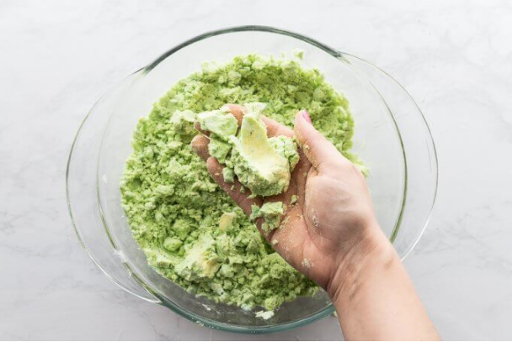

- Remember, it is always easier to add more water to your baking soda if needed, so start with less!
- Time to create the mold for your christmas tree! This can be done one of two ways. You can either take a paper plate and fold it into the shape of a cone or if you happen to have a snow cone cup around your house you may use that.
- Begin to pack your tree mold into the cone structure and pack them in nice and tight. This will ensure that your Christmas trees come out with a nice shape and wont fall apart.
- Create as many trees as you wish and once you have completed this step place them all on the baking tray and then pop them over to the north pole! (freezer)
- Leave your trees in the freezer for a minimum of two or three hours
- Once you feel they are ready you can pull them out and get ready for a mess!
- Remove all the paper plates and snow cone holders from your christmas trees.
- You will also need a cup full of vinegar and either a baster, eye dropper or even a spoon. You will slowly begin to pour the vinegar from your eye dropper on to the tree and watch as your Christmas tree takedown becomes one of the easiest tasks possible!

Resources:
- https://littlebinsforlittlehands.com/melting-christmas-tree-baking-soda-science-sensory-play/

Reach out!
We would love to hear from you about all the amazing STEM projects you are doing at home! Show us your finished products on any of the following social media platforms by tagging us or by using the following hashtags. We hope these projects have brought some excitement to your day during these difficult times.
Let us know how we did! Please click here to fill out a short survey on how well we did and what you would like to see more of in the future. Thank you!
Twitter: @MyMindsInMotion
Facebook: @mindsinmotion2014 & @ucactiveliving
Instagram: @ucalgaryactive

Please use the following hashtags!
#ucalgarycamps #ucalgarytogether

We hope you enjoyed our STEM Christmas activities! Everyone at Minds in Motion would like to wish you and those closest to you a happy holiday!

