Activity Rundown:
Coding and Christmas don't mix! Or do they? This holiday season Minds in Motion would like to give everyone the opportunity to incorporate coding into their holiday season. Together we will be creating Binary Christmas Keychains! Some say coding is the language of the future and today we will be using that language to get in the holiday spirit!

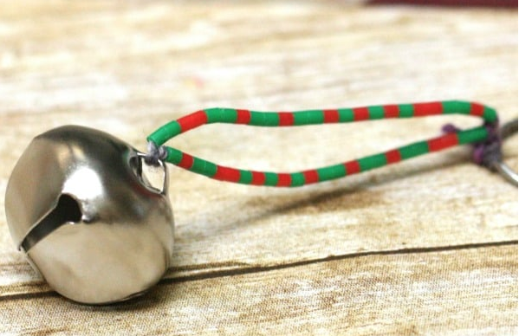

You will need:
- Beads (at least two colors)
- Key chain
- Bell
- Yarn or string
- Paper
- Binary chart (last page)

Let’s do it!
- To begin this project we must first understand what binary is and what it is used for! Binary is the most common text file used by computers and the internet to exchange information. It truly is like another language. Computers and the internet communicate through a series of codes using 1’s and 0’s. Stringing together these 1’s and 0’s in a certain sequence will equate to different messages!
- This leads us to our next step of figuring out what combination of 1’s and 0’s equal what! Down below on the final section of this document you will find a binary guide. This guide will give you the insight needed to create a coding sequence in which you will create your key chain from!
- Take your piece of paper and plan out what word you like to have as a theme for your keychain as this will dictate the color sequence. For example, Christmas, snowman, presents, wreath, or even your name! Any word will work.
- Next, below your chosen word you will write out the binary sequence for each letter. Once you have each letter written out it should look a little something like this:
- S - N - O - W
- 01010011 - 01001110 - 01001111 - 01010111
- Finally, you will assign one color for the 1’s and one color the 0’s. This will create a sequence all along your keychain. Begin to place the beads along the yarn or string to match your color coding sequence!

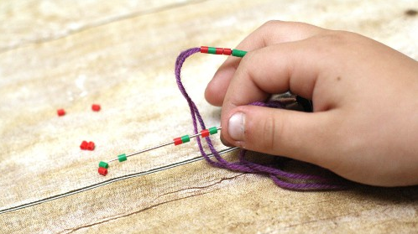

- Make sure you leave enough room for your bell and keychain! To recreate this activity with a friend or someone in your home you can simply give them the binary codes and let them figure out what word you have chosen!

Resources:
- https://rainydaymum.co.uk/christmas-stem-bell-key-chain/
- steampoweredfamily.com/activities/christmas-stem-activities/

Reach out!
We would love to hear from you about all the amazing STEM projects you are doing at home! Show us your finished products on any of the following social media platforms by tagging us or by using the following hashtags. We hope these projects have brought some excitement to your day during these difficult times.
Let us know how we did! Please click here to fill out a short survey on how well we did and what you would like to see more of in the future. Thank you!
Twitter: @MyMindsInMotion
Facebook: @mindsinmotion2014 & @ucactiveliving
Instagram: @ucalgaryactive

Please use the following hashtags!
#ucalgarycamps #ucalgarytogether

We hope you enjoyed our STEM Christmas activities! Everyone at Minds in Motion would like to wish you and those closest to you a happy holiday!
